COEN 160 OO Analysis, Design and Programming Winter 2017
TA: Michael Schimpf Email: mschimpf@scu.edu
TA Office Hrs: Tuesday 1:15 pm – 2:15 pm EC605, Thursday 5:00 pm – 6:00 pm EC618
Lab 3 (75 pts)
In this lab, you will work on exercises illustrating the concepts of interfaces, inheritance and copying arrays using System.arraycopy().
Using Eclipse, create a project called lab3.
All the exercises in this lab should be included in a package called, edu.scu.coen160.lab3.
Copy the posted files, Lab3_Q1.java, Lab3_Q2.java, Lab3_Q3.java, Lab3_Q4.java and Main.java into your working folder.
You will complete the code segments in each of the files using the comments in the code files and instructions given for each of the exercises. The program file, Main.java contains the main() which contains the code to run each of the tester methods in the program files. The main() in Main.java contains four (commented out) method calls to the tester() of each exercise. To compile the program, uncomment the Exercise you are testing and compile the Exercisenumber.java and Main.java. Run the program.
Exercise 1 (25 pts)
In this exercise, you will use the file, Lab3_Q1.java which contains 3 classes, namely, class Array, class Stack and class Lab3_Q1.
In this exercise, you will use class Array to implement class Stack. In this case, we are reusing class Array to implement class Stack’s functionality.
Hint: Use an instance of class Array as a data member of class Stack and complete the functionality of Stack.
Uncomment the line, Lab3_Q2.q1() in main() method in Main.java and compile the program. Run the program.
Based on your output, answer the following questions.
- If the stack does not have any elements and you issue a pop(), would your code work?
- If not, how would you fix it?
Exercise 2 (10 pts)
Examine the Java code below:
class PowerUser {}
class EmergencyLight extends PowerUser {}
class Computer extends PowerUser {}
class TV extends PowerUser {}

public class BuildingManager {
Asset things[] = new Asset[24];
int numItems = 0;

public void powerDownAtNight( ) {
for (int i=0; i<things.length; i++)
things[i].powerDown();
}

/** Add an Asset to this building */
public void add(Asset thing) {
things[numItems] = thing;
}

public static void main(String[] args) {
BuildingManager b1 = new BuildingManager( );

b1.add(new EmergencyLight());
b1.add(new Computer());
b1.add(new TV());
b1.powerDownAtNight( );
}
}

The scenario above (incomplete) is an attempt to represent the fact that things like EmergencyLight, Computer and TV are PowerUsers and are added to as assets to the building manager which powers down all the assets at night.

Currently, because of the incomplete type definitions and relationships, the code will not compile.
Make the necessary corrections to make the code compile and run. You may use one line of code (System.out.println(“powering down”) ) in powerDown() method.

The program is in Lab3_Q2.java

Exercise 3 (25 pts)
In this Exercise, you will use Java interfaces to create Lockable objects.
You will use the file, Lab3_Q3.java which contains 3 classes, namely, class Box, class Computer and class Lab3_Q3.
Objects of classes Box and Computer are considered Lockable and should have methods, lock() and unlock(). A box and Computer are really not closely related things, therefore, we use an interface called Lockable to enforce that both are Lockable.
The UML diagram below shows the relationship among Box, Computer and Lockable types.
Complete the code in Lab3_Q3.java using the comments given.
To compile the program, uncomment the line, Lab3_Q3.q3() in main() method in Main.java. Run the program.
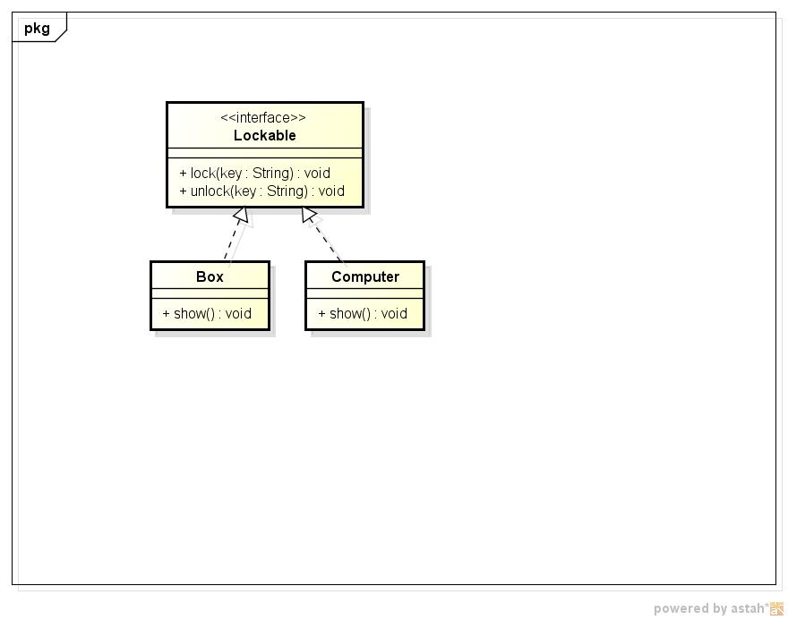

Exercise 4 (15 pts)
This exercise covers the topic of copying arrays using arraycopy().
The System.arraycopy method is used to copy data from one array into another:
Public static void arraycopy(Object from, int fromPos, Object to, int toPos, int howManyToCopy)
Examine the example code below:
char[] fromArray = { 'a', 'b', 'c', 'd', 'e', 'f', 'g','h', 'i','j', 'k', 'l', 'm'}
char[] toArray = new char[10];

System.arraycopy(fromArray, 2, toArray, 0, 10);
System.out.println(new String(toArray));

Ref: http://docs.oracle.com/javase/7/docs/api/java/lang/System.html
You are required to insert a new element in the middle of an array, using arraycopy(). In order to insert a new element in position i, you have to move all the elements from position i onward one position up and insert the new value.
Using the comments given, complete the code in Lab3_Q4.java.

